**Interaction result**

The chosen ligand exhibits a lower binding affinity compared to the known inhibitor, chlorpromazine. A lower binding affinity generally indicates a stronger interaction between the ligand and the target protein, suggesting that the ligand could potentially be a more effective drug candidate. Biovia and PyMOL are powerful tools used to visualize protein-ligand interactions in detail. By importing structures, preparing them, and using visualization techniques, researchers can identify key interactions like hydrogen bonds and hydrophobic contacts. These tools can generate high-quality images and animations to illustrate the binding mode and aid in drug design

.

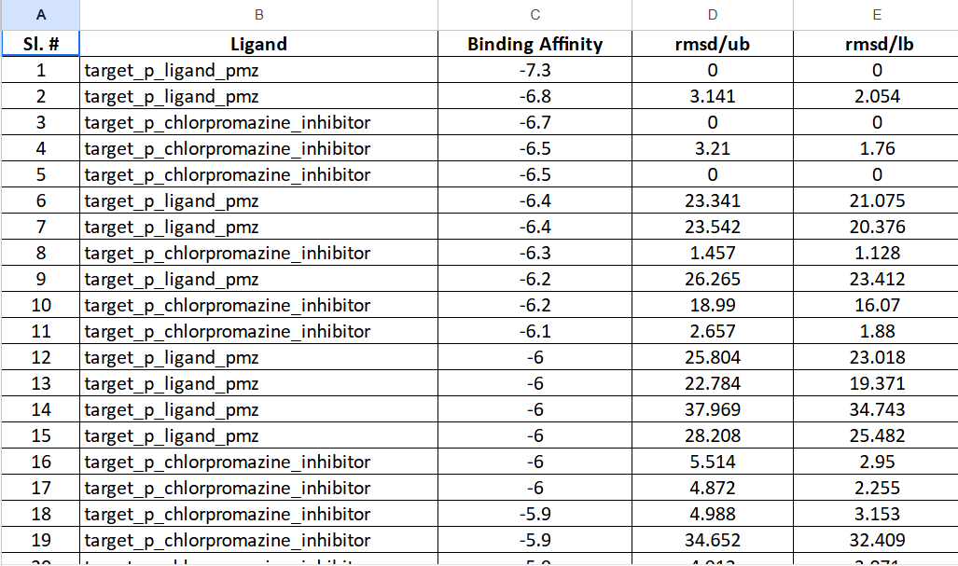

Based on the docking studies, the chosen ligand exhibits a lower binding affinity compared to the known inhibitor, chlorpromazine, indicating a potentially stronger interaction with the target protein. However, while this is a promising sign, further analysis, including molecular dynamics simulations and experimental validation, is necessary to fully assess its potential as a drug candidate, considering factors like selectivity, toxicity, solubility, and metabolic stability.

This suggests a stronger interaction between the chosen ligand and the target protein, which is a promising sign for a more potent and effective drug candidate.

Biovia tool is used to visualise the molecule and study its properties and further analysis, possibly to foresee the interactions or perform additional calculations.

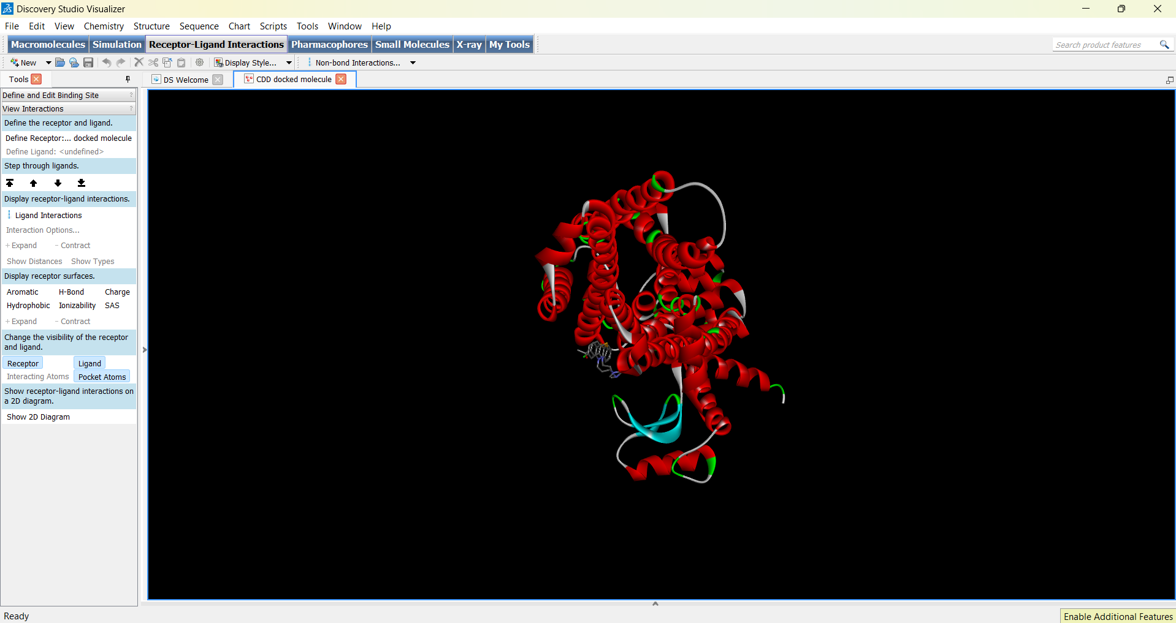

After analysing it is subjected to PyMol tool to study the properties of the ligands and the receptor target.

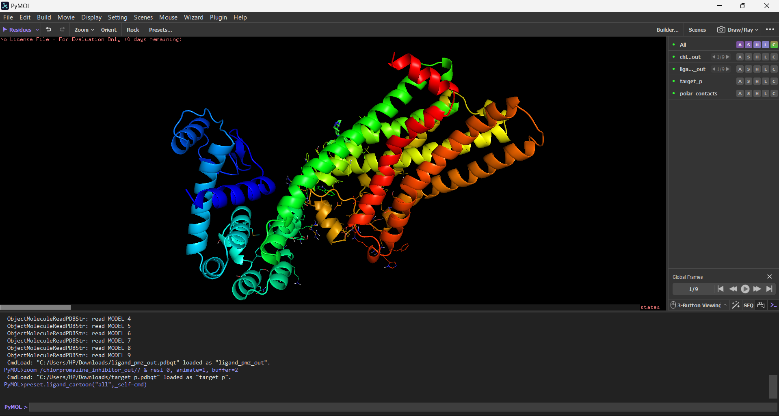

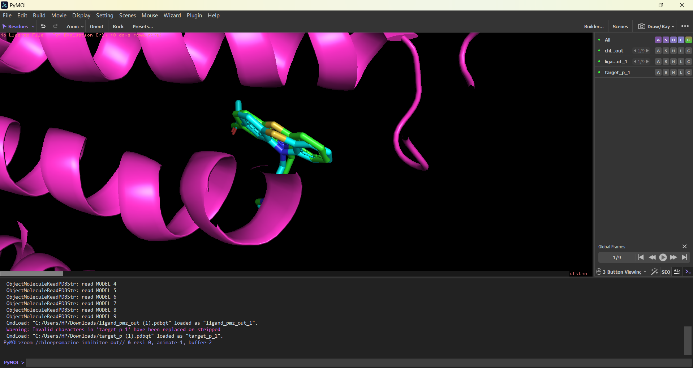

**Protein and inhibitor interaction**

Protein-inhibitor interactions are a specific type of protein-ligand interaction where the ligand, or inhibitor, binds to the protein to block its function. This can be achieved through competitive inhibition, non-competitive inhibition, or uncompetitive inhibition. By understanding the molecular details of protein-inhibitor interactions, researchers can develop more effective drugs.

Chlorpromazine is a typical antipsychotic medication that primarily works by blocking dopamine receptors in the brain. It binds to dopamine D2 receptors, preventing dopamine from activating these receptors. This disruption in dopamine signalling helps to alleviate symptoms of psychosis, such as hallucinations and delusions.

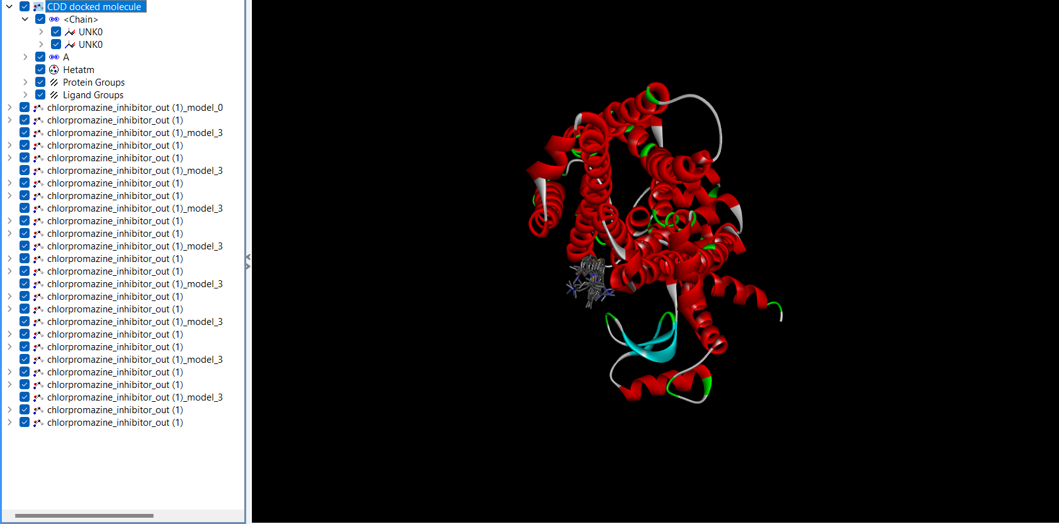

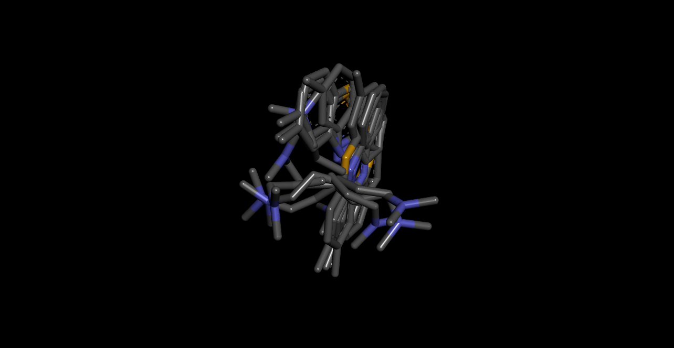

**Protein and Ligand interaction**

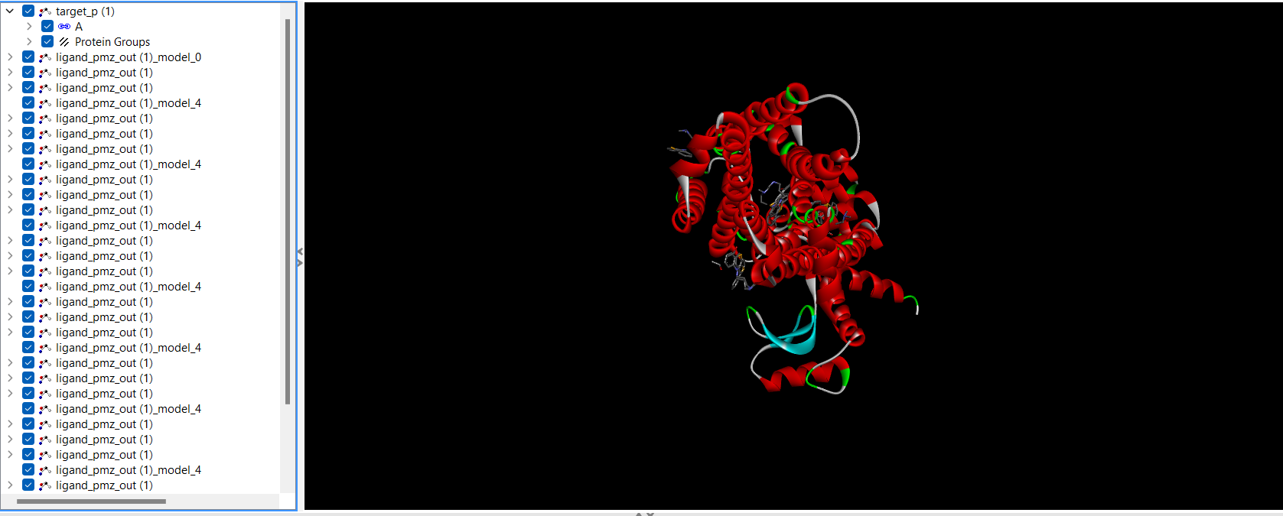

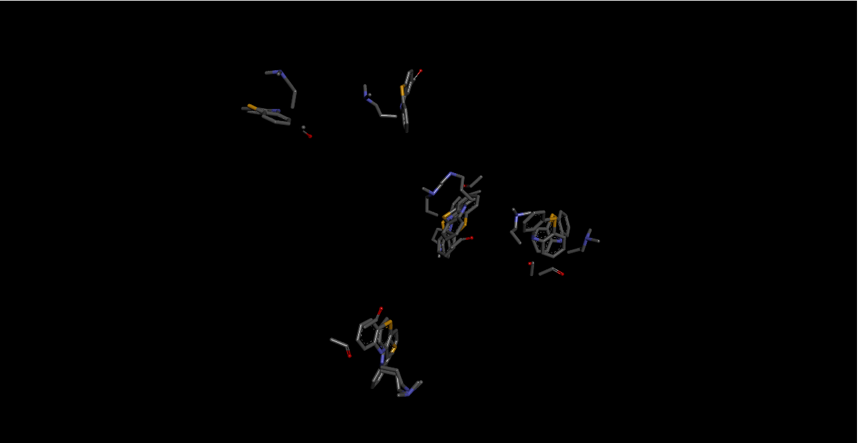

Protein-ligand interactions are fundamental to many biological processes, including enzyme catalysis, signal transduction, and drug action. When a ligand, such as a drug molecule, binds to a protein, it forms a complex that can induce conformational changes in the protein, leading to a specific biological response. The strength and specificity of these interactions are determined by various factors, including hydrogen bonding, ionic interactions, van der Waals forces, and hydrophobic interactions.

**Ligand-Protein Interactions**

Hydrogen Bonds: Neither the ligand nor the inhibitor forms hydrogen bonds with the target protein.

Other Interactions: The binding interactions likely involve other forces such as van der Waals forces, hydrophobic interactions, and possibly pi-pi stacking.

**Result**

Therefore, the result indicates that:

1. Binding Affinity: The chosen ligand exhibits a lower binding affinity compared to the conventional drug molecule, chlorpromazine. A lower binding affinity generally indicates a stronger interaction between the ligand and the target protein, suggesting that the ligand may have a higher potency and efficacy.
2. Binding Site: Both the ligand and chlorpromazine likely bind to the same active site on the target protein, given their structural similarity.
3. Hydrogen Bonding: Neither the ligand nor chlorpromazine appears to form hydrogen bonds with the target protein. Other intermolecular forces, such as van der Waals forces and hydrophobic interactions, may be driving the binding.

LigPlot is a powerful tool for visualizing protein-ligand interactions in 2D. It generates schematic diagrams that highlight key interactions, including hydrogen bonds, hydrophobic contacts, and pi-pi stacking. Interactions:

Protein Backbone: The protein backbone is typically represented as a series of lines or tubes.

Side Chains: Amino acid side chains involved in interactions are shown as lines and labeled with their one-letter codes.

Ligand: The ligand molecule is represented as a stick or ball-and-stick model.

Hydrogen Bonds: These are depicted as dashed lines between hydrogen bond donor and acceptor atoms.

Hydrophobic Contacts: These are indicated by shaded areas or lines, highlighting regions of non-polar interaction.

Pi-Pi Stacking: Aromatic rings that interact through pi-pi stacking are shown with overlapping shaded areas.

